COMP20008 Assignment 2
Operational Strategy or Listing Fundamentals?
Predicting Superhost Status in the Melbourne Short-Term Rental Market
Group name | W[XX]G[XX]
Group members | Full name (Student ID) — one per line

Introduction
State your research question, why it matters, and briefly introduce the dataset(s) you use to address it. Set the context a reader needs before the Methodology section.

Methodology

Data Preprocessing
Six candidate preprocessing steps are proposed for this Melbourne Airbnb dataset, aligned with the research question (RQ): whether superhost status is more closely associated with inherent property attributes or host operational strategies. Three steps are selected and implemented, while the remaining three are discarded based on empirical evidence from the dataset and their limited explanatory value for the RQ.
The six candidate steps are:
1. Derive days_since_last_review from the raw last_review date field
2. Calculate amenity_count by parsing the structured amenities field
3. Handle missing price values via median imputation plus a missing indicator variable
4. Impute missing values for the bedrooms and beds fields
5. Consolidate categories for the property_type variable
6. Discretise minimum_nights into grouped stay-length bins
Justification for Discarding Three Candidate Steps
Discarded: bedrooms/beds imputation
Missingness is 18.19% for bedrooms and 27.44% for beds, and is semantic rather than random: only 2.47% for entire homes/apartments against 61.28% for private rooms and 66.67% for shared, a roughly 25-fold gap.
The definition of “bedroom count” is therefore ambiguous for shared and private accommodation, and any median imputation would impose artificial values and systematic bias; guest capacity is already captured by accommodates, so this step is abandoned.
Discarded: property_type category consolidation
Of the 82 property_type categories, 41 have fewer than 10 observations, yet these 41 categories together account for only 111 rows (0.43% of the dataset) — the maximum possible gain from consolidation is therefore negligible.
Merging these groups lacks objective classification rules and would introduce subjective bias. There is also little empirical need: Entire home/apt already accounts for 73.18% of listings and, within it, Entire rental unit makes up 59.81%, and the largest subtype exceeds half in three of the four room types. With observations concentrated in identifiable subtypes and the long tail negligible, merging would add overfitting risk without benefit, so this step is discarded.
Discarded: minimum_nights discretisation
Binning minimum stays into short, medium and long (≥30 nights) groups was considered, but only 426 listings (1.66%) require 30 nights or more.
The long-stay category’s extreme imbalance would prevent stable patterns, tree splits on the binned variable would overfit, and it has weak explanatory power for the RQ; this step is therefore abandoned.
Selected Preprocessing Steps and Rationale
Step 1: Derive days_since_last_review from last_review
Relevance to the research question
This variable falls on the operational strategy side of the RQ framework. Review recency reflects a host’s recent service quality and operational activity. Guest reviews can only be submitted after a completed stay, so this variable acts as a strong proxy for how actively a host manages their listing — a key behavioural marker of superhost status.
Data properties and implementation
last_review is ISO-formatted, so standard datetime parsing applies; days_since_last_review is computed against the dataset maximum date (2026-06-28), not the system date, to avoid time-drift bias. Of the listings, 4,477 (17.4%) have empty last_review. Listwise deletion would bias the sample (zero-review superhost rate 6.59% vs 35.72%, inflating the positive rate to 35.72%) and median imputation (84 days) would wrongly encode them as recently active, so these rows are filled with 4,594 days (the reviewed maximum plus one) with a binary has_review indicator, applying the same ‘missingness itself carries signal’ approach used for price.
Although has_review is a coarsened form of an official metric we exclude, it is no stand-in for the label: the official threshold (Airbnb, 2026) is far stricter than the ever-reviewed distinction, and 295 zero-review listings are superhosts, 271 of them on hosts with a reviewed listing. The indicator therefore preserves genuine signal without collapsing into the label.
The official Superhost criteria, assessed every three months over the trailing 12 months, include at least 10 completed stays (or three reservations totalling at least 100 nights), a 4.8 or higher overall rating, a 90% response rate within 24 hours and a cancellation rate below 1% (Airbnb, 2026).
Step 2: Calculate amenity_count from the amenities field
Relevance to the research question
This variable is also operational: fixed attributes such as location and size are hard to modify, whereas amenities (e.g. high-speed Wi-Fi, baby cots) are discretionary host investment, testing whether richer provision can offset weaker core attributes.
Data properties and implementation
The raw amenities field is a JSON string of comma-separated compound terms; splitting on commas splits single amenities whose names contain commas, over-counting systematically, so proper JSON deserialisation corrects the error.
Step 3: Price missing value handling (median imputation + missing indicator)
Relevance to the research question
Price reflects a host’s pricing strategy and market positioning and sits on the operational side of the RQ; dropping missing-price rows would distort the distribution and bias analysis of superhost pricing.
Data properties and implementation
Price missingness is MAR rather than MCAR, depending strongly on availability_365:
- P(missing | availability_365 > 0) = 0.0222
- P(missing | availability_365 = 0) = 0.9985
Delisted listings have an 8.13% superhost rate against 37.68% for active listings, and deletion would inflate the positive rate, so missing values are imputed with the global median ($243.67) with a binary price_missing feature preserving the delisting signal.

Correlation Analysis
Variable set and rationale
The research question asks whether superhost status is more closely associated with listing fundamentals or host operational strategy, so the exploratory variable set must include pure representatives on both sides of this dichotomy, together with the target variable. The five variables selected are host_listings_count, days_since_last_review, availability_365, dist_cbd, and the binary target y (host_is_superhost).
On the fundamentals side, dist_cbd is the cleanest probe of location determinism: distance from the Melbourne CBD is a fixed physical attribute no host effort can change. price is excluded because it is ultimately a host pricing decision sensitive to seasonal factors, so classifying it as a fundamental would blur the dichotomy, and its 25.47% imputation rate would weaken coefficient reliability; accommodates is reserved for the full feature set.
On the operational side, three dimensions characterise hosts. host_listings_count captures scale and professionalisation (heavy-tailed; median 2, 75th percentile 14, maximum 667). days_since_last_review measures recent activity, testing whether dormant listings are delisted (median 84 days, maximum 4,593). availability_365 reflects calendar positioning, with 21.8% of listings at 0 (fully delisted) and only 1.56% at 365.
The binary target y is included because the specification requires it; it yields four direct predictor–target associations, provides the context for the point-biserial applicability discussion below, and establishes a baseline for later feature selection.
Set size is fixed at five: 10 pairs give 40 values (10 pairs × 4 methods), which fit in one table while leaving room to analyse method divergence; six variables would give 15 pairs and 60 values, forcing superficial treatment. The set is tilted 3:1 toward operational features; the full feature set in later sections restores the fundamentals dimension.
Implementation choices
MI and NMI require discrete input, so continuous variables are binned using equal-frequency rather than equal-width bins: equal-width ten-bin bins concentrate 91.4% of host_listings_count rows in one bin (84.6% at twenty bins), depressing MI. N_BINS = 10 gives roughly 212 rows per bin; 20 bins would give 53, too sparse. qcut with duplicates="drop" handles the 21.8% zero pile in availability_365, leaving 10, 10, 8 and 7 actual bins. MI is binning-sensitive (0.1175 at five bins to 0.2499 at twenty, +113%), while NMI moves only 0.0799→0.0896 (+12%), so cross-pair interpretation rests on NMI.
Since the target y is binary, Pearson on each predictor–y pair reduces to the point-biserial correlation — valid but outlier-sensitive — while Spearman becomes its rank-based, outlier-robust counterpart; MI and NMI remain fully applicable to binary variables.
Correlations were computed on the 21,251 listings with at least one review, because the 4,477 zero-review listings carry the fill value 4,594 for days_since_last_review, which would create an artificial pile-up at the maximum and distort the coefficients, particularly Pearson.

Supervised Learning Models and Evaluation
All 25,728 listings were used, including the 4,477 zero-review listings, whose presence is communicated by has_review; removing them would inflate the positive rate from 30.65% to 35.72%. The 11 features comprise three fundamentals (room_type_3, dist_cbd, accommodates) and eight operational features (availability_365, amenity_count, days_since_last_review, has_review, price_num, price_missing, minimum_nights, host_listings_count), specified as a whitelist so columns encoding the official criteria or derived from reviews (e.g. review_scores_rating, number_of_reviews) cannot enter. Shared room and Hotel room (283 together) were merged into Other.
A group-aware stratified split (StratifiedGroupKFold grouped by host_id) held out 20% of listings; grouping is required because 55.76% of listings belong to multi-listing hosts and the target is constant within host, so a random split would leak hosts across sets. Preprocessing sat in a Pipeline fitted on training folds only: prices were imputed with the training-fold median (removing the minor global-median leakage noted in Preprocessing) and room type one-hot encoded. Features were standardised only for KNN; the tree stayed unscaled so its split points keep their units.
A majority-class baseline, K-Nearest Neighbours and a Decision Tree were compared; one distance-based and one rule-based learner already give a contrast, so no optional third model was added. Hyperparameters were selected by five-fold grouped cross-validation on macro-F1, searching k in {1, 5, 11, 21, 51, 101, 151, 201, 301} and tree depth in {2, 3, 4, 5, 6, 8, 10, 15, None}; the KNN grid was extended to 301 until scores declined, confirming an interior peak. The test set was used once. Macro-F1 is the primary metric because positives account for 30.65% of listings and a majority-class classifier already reaches 69.35% accuracy while finding no superhosts; per-class precision, recall and F1 are reported, with 95% intervals from a paired host-level bootstrap (1,000 resamples). Six feature subsets (A–F, Table 4) were then run with fixed hyperparameters, compared by CV macro-F1 and paired bootstrap for B versus A and F versus A.

Feature Selection
One filter and one embedded method were used, on the training set only. The filter method used mutual_info_classif to estimate each feature’s mutual information with the target independently, which detects non-linear dependence such as the inverted-U in host_listings_count that Pearson and Spearman miss; room type was integer-encoded, the discrete features (room_type_3, has_review, price_missing) declared and remaining missing values filled with the training median. These continuous-value MIs are not comparable to the binned MI in Table 1. The embedded method used the tuned depth-5 tree’s impurity importance, summing the one-hot room-type columns. Each top three was validated by retraining both models against the full set, with test-set permutation importance (10 repeats) cross-checking the bias toward continuous features with many split points. The hard case was the missed superhost, from the model with the higher CV score, with the lowest predicted probability, compared against both classes’ training medians. RFE was rejected for its retraining cost and PCA because its mixed components cannot be labelled by group.

Dimensionality Reduction & Clustering (groups of four only)
- Name 3 candidate feature sets for clustering, justify your choice, and apply it to both K-Means and Hierarchical clustering.
- Apply PCA to the same feature set.

Results Exploration and Analysis

Data Preprocessing
Step 1: Derive days_since_last_review from last_review
Quantitative impact (Before / After)
Before: 4,477 rows (17.4%) have an undefined days_since_last_review because they have never received a review.
After: has_review flags these rows, days_since_last_review is filled with 4,594, and the missing count falls to zero.
Downstream validity
Among reviewed listings the median days_since_last_review is 84.0 days; superhosts average 93.10 days versus 727.03 for non-superhosts, a 7.81-fold difference (means exclude zero-review rows, which carry the fill value). Zero-review listings have a 6.59% superhost rate against 35.72% for reviewed listings, confirming review recency carries clear signal.
Step 2: Calculate amenity_count from the amenities field
Quantitative impact (Before / After)
Before: naive comma splitting fragments compound names such as “HDTV with Chromecast, DVD player”, disagreeing with the correct count on 3,096 of 25,728 rows (12.03%), over-counting by up to 21 on one listing.
After: JSON deserialisation resolves the compound terms; only 29 listings (0.11%) with genuinely empty lists remain at zero.
Downstream validity
After calibration, superhosts average 44.08 amenities against 31.03 for non-superhosts (gap 13.05), confirming amenity richness differentiates superhosts.
Step 3: Price missing value handling (median imputation + missing indicator)
Quantitative impact (Before / After)
Before: 6,553 rows have missing price values, representing 25.47% of the sample.
After: all missing prices are filled with the median (missing rate 0%), with price_missing retaining the delisting information.
Stability evidence
Ten 75% subsamples give $243.0–$245.0 (0.82%), confirming no meaningful leakage.

Correlation Analysis
Table 1. Pairwise correlation coefficients and information-theoretic scores (n = 21,251 listings with at least one review)
Pair | Pearson | Spearman | MI | NMI | Bins
DSLR ~ AV365 | −0.438 | −0.395 | 0.1829 | 0.0856 | 10×8
DSLR ~ SH | −0.337 ‡ | −0.443 ‡ | 0.1159 | 0.0785 | 10×2
AV365 ~ SH | 0.146 ‡ | 0.155 ‡ | 0.0425 | 0.0324 | 8×2
HLC ~ DIST | −0.131 | −0.225 | 0.0580 | 0.0285 † | 7×10
HLC ~ DSLR | −0.113 | −0.194 | 0.0558 | 0.0274 † | 7×10
HLC ~ AV365 | 0.059 | 0.225 | 0.0430 | 0.0230 † | 7×8
AV365 ~ DIST | 0.170 | 0.124 | 0.0315 | 0.0147 † | 8×10
DSLR ~ DIST | −0.081 | 0.061 | 0.0317 | 0.0138 † | 10×10
HLC ~ SH | −0.069 ‡ | 0.070 ‡ | 0.0117 | 0.0097 | 7×2
DIST ~ SH | 0.076 ‡ | 0.009 ‡ | 0.0070 | 0.0047 | 10×2
Variables are abbreviated as HLC (host_listings_count), DSLR (days_since_last_review), AV365 (availability_365), DIST (dist_cbd) and SH (superhost status).
† MI and NMI depend on the binning scheme; actual bin counts are shown in the Bins column.
‡ The target is binary, so Pearson reduces to a point-biserial correlation and Spearman to its rank-based counterpart.
Table 1 reports all four correlation measures for every pairwise combination in the five-variable set — 10 pairs × 4 methods = 40 values. Pairs are sorted in descending order of NMI, the only measure that supports cross-pair comparison after the binning-sensitivity analysis in the Methodology.
The strongest predictor pair is DSLR ~ AV365 (NMI 0.0856, all methods negative) and the strongest target pair is DSLR ~ SH (0.0785); at the other end, DIST ~ SH is near zero across all four methods (0.076, 0.009, 0.0070, 0.0047), so no measure associates CBD distance with status.
Several pairs diverge by method: HLC ~ SH and DSLR ~ DIST both show sign reversals (Pearson −0.069 / −0.081 vs Spearman +0.070 / +0.061), and the largest Pearson–Spearman gap is HLC ~ AV365 (0.059 vs 0.225, difference 0.166).

Supervised Learning Models and Evaluation
The split produced a test set of 4,945 listings (19.2%) from 2,820 hosts, with no host overlap; positive-class rates were 31.2% in training and 28.4% in testing.
Table 2. Cross-validated macro-F1 per candidate hyperparameter (five grouped folds; majority-class baseline CV = 0.408).
KNN k | 1 | 5 | 11 | 21 | 51 | 101 | 151 | 201 | 301
CV macro-F1 | .623 | .646 | .654 | .660 | .671 | .675 | .671 | .669 | .671
DT max depth | 2 | 3 | 4 | 5 | 6 | 8 | 10 | 15 | None
CV macro-F1 | .682 | .687 | .691 | .696 | .688 | .694 | .694 | .675 | .644
KNN macro-F1 peaked at k = 101 (0.675) and declined at larger values, while the tree peaked at depth 5 (0.696), with the unrestricted tree at 0.644.
Table 3. Test-set performance (the test set was used once).
Model | Macro-F1 [95% CI] | Accuracy | Superhost P / R / F1 | Non-superhost F1 | FN / FP
Baseline | 0.417 | 0.717 | 0 / 0 / 0 | 0.835 | 1,402 / 0
KNN (k = 101) | 0.701 [0.676, 0.722] | 0.756 | 0.570 / 0.573 / 0.572 | 0.830 | 598 / 607
DT (depth 5) | 0.721 [0.693, 0.749] | 0.777 | 0.613 / 0.581 / 0.596 | 0.846 | 588 / 514
Paired host-level bootstrap intervals: DT minus KNN macro-F1 [−0.002, 0.046].
Both models scored well above the baseline, which reached 0.717 accuracy but only 0.417 macro-F1. Both had superhost recall of about 0.58, missing 598 and 588 of 1,402 test superhosts, while the tree produced fewer false positives (514 vs 607).
Table 4. RQ feature-subset experiments; hyperparameters fixed at the values tuned on the full feature set.
Set | Features | n | DT CV macro-F1 | KNN CV macro-F1 | DT test macro-F1
A | Fundamentals only | 3 | 0.485 | 0.495 | 0.500
B | Operational only | 8 | 0.701 | 0.676 | 0.727
C | All 11 (control) | 11 | 0.696 | 0.675 | 0.721
D | All, review pair removed | 9 | 0.672 | 0.656 | 0.680
E | All, availability_365 removed | 10 | 0.698 | 0.667 | 0.724
F | Operational, review pair removed | 6 | 0.670 | 0.652 | 0.681
Paired host-level bootstrap intervals (DT test): B minus A [0.184, 0.266]; F minus A [0.130, 0.231].
Fundamentals-only CV macro-F1 was 0.485 against 0.701 for operational features; removing availability_365 left the tree score unchanged (0.698 vs 0.696).

Feature Selection
Table 5. Feature rankings from the filter and embedded methods (training set) with test-set permutation importance.
Feature | Group | Filter MI (rank) | Embedded importance (rank) | DT permutation | KNN permutation
days_since_last_review | Op | 0.136 (1) | 0.742 (1) | 0.137 | 0.043
host_listings_count | Op | 0.113 (2) | 0.125 (2) | 0.031 | 0.011
availability_365 | Op | 0.087 (3) | 0.008 (6) | 0.000 | 0.031
amenity_count | Op | 0.073 (4) | 0.102 (3) | 0.082 | 0.087
price_num | Op | 0.067 (5) | 0.004 (7) | 0.000 | 0.008
price_missing | Op | 0.045 (6) | 0.000 (8) | 0.000 | 0.036
dist_cbd | Fund | 0.035 (7) | 0.010 (4) | 0.003 | 0.013
has_review | Op | 0.035 (8) | 0.000 (8) | 0.000 | 0.001
room_type_3 | Fund | 0.014 (9) | 0.000 (8) | 0.000 | 0.005
minimum_nights | Op | 0.010 (10) | 0.009 (5) | 0.002 | 0.003
accommodates | Fund | 0.006 (11) | 0.000 (8) | 0.000 | 0.002
Top-three validation (DT CV / DT test / KNN CV): embedded top three 0.702 / 0.729 / 0.670; filter top three 0.666 / 0.685 / 0.672; all 11 features 0.696 / 0.721 / 0.675.
The filter top three were days_since_last_review, host_listings_count and availability_365, and the embedded top three were days_since_last_review, host_listings_count and amenity_count; the four distinct selected features are all operational. The largest ranking gaps were availability_365 (filter 3, embedded 6), has_review (filter 8, tree importance 0) and dist_cbd (embedded 4, but permutation importance no greater than 0.013 for either model). The hard case, listing 46835268, had a superhost probability of 0.0014: 813 days since its last review against class medians of 37 and 503.5 days, availability_365 of 77 (medians 195 / 106) and dist_cbd of 27.2 km; its host has one listing with 12 reviews.

Dimensionality Reduction & Clustering (groups of four only)
Present explained variance per component, top-3 loadings per component, and cluster summaries from K-Means and Hierarchical clustering.

Discussion and Interpretation

Data Preprocessing
The three preprocessing steps differ in their implications for the research question. For Step 1, the key implication concerns the 4,477 zero-review listings: their superhost rate is 6.59% against 35.72% for reviewed listings, and deleting them would inflate the positive rate from 30.65% to 35.72%; among reviewed listings, the 7.81-fold days_since_last_review gap (93.10 vs 727.03 days) still holds. For amenity_count, 12.03% of rows differ between naive and correct parsing and the superhost gap (13.05 amenities) is far smaller than the review-recency gap, so the information is complementary. For price, missingness itself carries signal: delisted listings have a superhost rate of 8.13% versus 37.68% for active listings (4.6-fold), so either deletion or imputation without an indicator would erase this operational signal. Across the steps, preprocessing follows the RQ: missingness carrying an operational signal is retained (price), while missingness reflecting only room-type semantics is discarded (bedrooms).

Correlation Analysis
Pearson captures only linear and Spearman only monotonic associations, so both are pushed toward zero for non-monotonic relationships while MI and NMI, which assume no shape, still detect dependence. For HLC ~ SH, Pearson −0.069 and Spearman +0.070 have opposite signs while NMI stays non-zero (0.0097). Figure 1 shows the inverted-U: the rate is 28.48% for hosts with at most one listing (n = 8,103), peaks at 46.08% for 3–5 listings (n = 2,832) and falls to 16.92% for over 100 (n = 1,259). The raw right tail (up to 667) pulls Pearson negative; ranking compresses it, letting the rise dominate for Spearman.
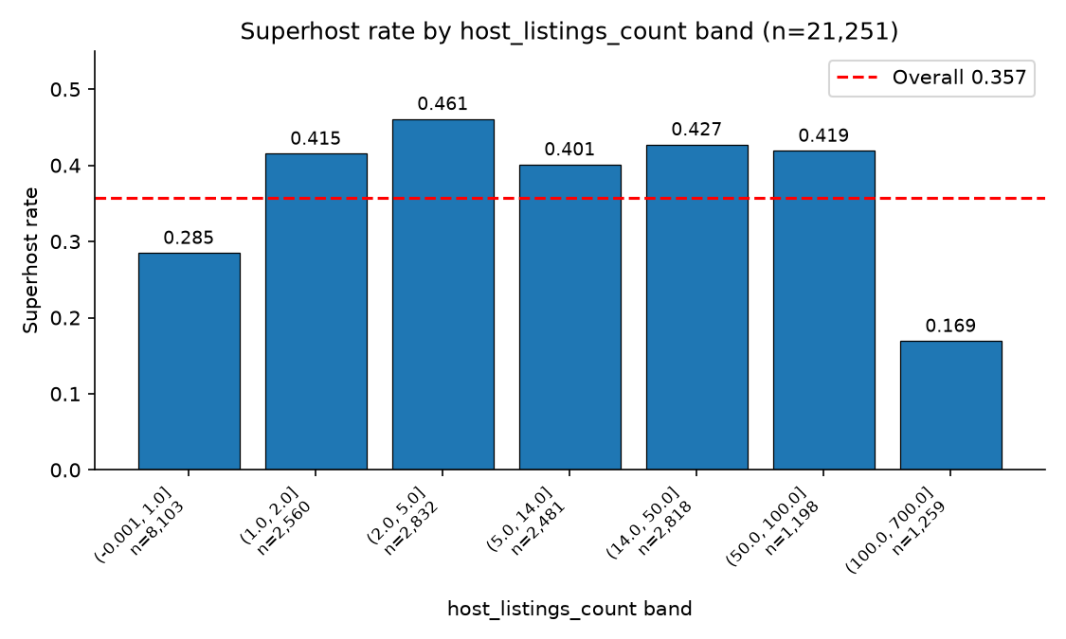
Figure 1. Superhost rate by host_listings_count band (n = 21,251), showing an inverted-U pattern. The dashed line marks the overall rate of 0.357.
The same cancellation occurs for DSLR ~ DIST (Pearson −0.081, Spearman +0.061, NMI 0.0138): Figure 2 shows median days_since_last_review lowest within 1.4 km (41–60), jumping to 111 at 1.7 km, peaking near 122 around 5 km and falling to 47 at the outermost band (50.6 km); the rise-then-fall cancels in the linear measures, and the 1.5 km step may mark the CBD grid edge, though speculatively.
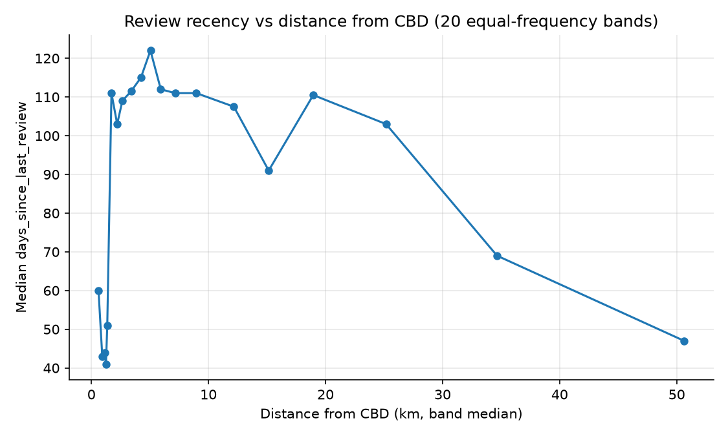
Figure 2. Median days_since_last_review across 20 equal-frequency distance bands from the Melbourne CBD.
For the RQ, the predictor–target pairs rank DSLR (0.0785), AV365 (0.0324), HLC (0.0097), DIST (0.0047): the strongest operational variable leads while the sole fundamental has the lowest NMI of all ten pairs. The HLC inverted-U likewise shows scale itself does not track status, with mid-sized hosts (3–5 listings) highest at 46.08% and large operators (>100) at 16.92%. These patterns point toward how a listing is operated rather than how many are owned or where, though preliminarily; because the set is tilted 3:1 operational, the full feature-set analysis below provides the decisive test.
The strongest predictor pair DSLR ~ AV365 (NMI 0.0856; Pearson −0.438, Spearman −0.395) suggests information overlap; the controlled comparison (full set vs availability_365 removed, DT CV 0.696 vs 0.698) shows availability_365 adds no measurable score once review recency is present.
These associations are not causal. Hosts with over 100 listings may operate long-term or business-apartment models, so their low rate may reflect business model rather than quality. The 21,251 reviewed listings come from 11,474 hosts, so observations are not fully independent; and days_since_last_review proxies last review date, not last transaction, as not every guest reviews.

Supervised Learning Models and Evaluation
With the official criteria excluded, the tree and KNN reached test macro-F1 of 0.721 and 0.701 against the baseline’s 0.417, indicating substantial signal in the 11 features. Status is therefore inferable, but only partially: both models missed about 42% of test superhosts (recall 0.581 and 0.573).
The tree scored slightly above KNN, but the paired interval [−0.002, 0.046] includes zero, so the two are comparable; the tree did produce fewer false positives (514 vs 607). Its small edge may reflect the signal’s structure: importance is concentrated in days_since_last_review, whose threshold-like association a shallow tree captures in a few splits, whereas KNN weights every scaled feature equally, letting weak fundamentals add noise. The tree’s practical advantage is interpretability rather than score.
The models rely on different features: the tree depends almost entirely on days_since_last_review (0.742 impurity; 0.137 permutation), while KNN spreads across amenity_count (0.087), days_since_last_review (0.043), price_missing (0.036) and availability_365 (0.031). After the tree splits on review recency, price_missing (associated with delisting, P(missing | availability = 0) = 0.9985) and availability (NMI 0.0856 with review recency, Table 1) add little. Which features matter therefore depends on the model.
The subset experiments address the RQ most directly. Fundamentals-only tree CV macro-F1 was 0.485, only slightly above the baseline CV 0.408, while operational-only features reached 0.701, paired interval [0.184, 0.266], and were not below the full set (0.701 vs 0.696), so fundamentals added little — consistent with DIST ~ SH’s NMI of 0.0047, the lowest in Table 1. The result is not carried by review recency alone: operational features without the review pair reached 0.670 (F minus A [0.130, 0.231]), though set D’s 0.025 decline shows review recency contributes a share. The superhost programme may reward hosting activity and service quality, which operational features describe, while location and room type are only weakly associated with differences between hosts.

Feature Selection
The lists agree on days_since_last_review and host_listings_count, the reliable core. host_listings_count is notable: its Pearson and Spearman were near zero (−0.069, +0.070) owing to the inverted-U, yet it ranks second under both MI and tree importance, so both methods recovered the non-linear dependence the linear measures missed, corroborating the Correlation Analysis. The third-feature disagreement follows from each method: the filter evaluates features independently, and availability_365 is strongly associated with the target alone, but it overlaps heavily with days_since_last_review (NMI 0.0856, Pearson −0.438), leaving little after the tree splits on review recency (embedded rank 6); amenity_count instead adds information review recency lacks. The cost shows in validation: the embedded top three scored 0.702 against 0.666 for the filter top three. Conversely, dist_cbd ranked fourth by embedded importance but seventh by the filter, with permutation importance no greater than 0.013, illustrating the bias toward continuous features with many split points.
The hard case, listing 46835268, received a superhost probability of 0.0014: no review for 813 days (superhost median 37), 77 available days, 27 km from the CBD and a single-listing host. It looks dormant, so the prediction is consistent with the data; it is not isolated — 89 test superhosts had no review for over a year and the tree identified none, with median days_since_last_review of 106 for false negatives versus 27.5 for true positives. One possible, unverifiable explanation is a time-window mismatch: status assessed on a trailing period may persist after the listing becomes inactive, or stays occurred without reviews, leaving some superhosts structurally unidentifiable from snapshot features.

Dimensionality Reduction & Clustering (groups of four only)
Interpret what each component and cluster represents, and whether K-Means and Hierarchical produced materially different groupings.

Limitations and Improvement Opportunities

Preprocessing
Median imputation assigns $243.67 to 6,553 missing rows, 93.35% of them delisted; their true prices may differ, and price_missing preserves missingness but not value. The global median also gives minor leakage ($243.0–$245.0 across ten subsamples, <1%). amenity_count ignores quality (a Wi-Fi router and pool carry equal weight). Bedroom imputation was rejected as Private rooms show 61.28% missingness versus 2.47% for entire homes.
days_since_last_review has Spearman −0.8155 with number_of_reviews_ltm, so it is a partial proxy for the excluded review-volume criterion, as is has_review; the with/without comparison (set D, 0.672 vs 0.696 CV) puts its contribution at about 0.025 macro-F1.

Correlation
The 21,251 reviewed listings come from 11,474 hosts and the target is constant within host, so the effective sample size is smaller than nominal; with this size nearly any coefficient reaches significance (HLC ~ SH, Pearson −0.069, would be declared significant), so interpretation rests on effect size. MI is binning-dependent (0.1175 to 0.2499, +113%, for DSLR ~ AV365) while NMI moves 0.0799→0.0896 (+12%), so cross-pair judgements rest on NMI; equal-width binning and a six-variable set were rejected for the reasons above.
Table 1 excludes the 4,477 zero-review listings (17.4%; superhost rate 6.59%), so it describes reviewed listings only and should not be generalised to the full 25,728.

Supervised Learning
Unequal group sizes. The operational group has eight features against three fundamentals, so the subset comparison is asymmetric; set F (six features) partly addresses this.
Review-activity proxy. The review pair partly proxies excluded review-volume metrics (see Preprocessing limitations).
Fixed hyperparameters. k = 101 and depth 5 were reused across subsets, whose own optima may differ, so subset scores may be slightly underestimated.
Class-rate difference. The test positive rate (28.4%) was below training (31.2%), and the test score (0.721) exceeding CV (0.696) may partly reflect this.
Snapshot timing. Eighty-nine test superhosts had been inactive over a year and none was detected, possibly reflecting the time-window mismatch discussed above.
Approaches not pursued. A third model and class weighting, which would target recall rather than macro-F1, were omitted.

Feature Selection
Impurity-importance bias. As the dist_cbd example shows (embedded rank 4, permutation importance no greater than 0.013), impurity importance favours continuous features with many split points.
Correlated features shield one another. When days_since_last_review is permuted, has_review remains, and when availability_365 is permuted, days_since_last_review remains, so each overlapping feature’s importance is understated; grouped permutation of correlated features would address this.
Fixed number of features. Only the top three were evaluated, as the assignment specifies; top two or top four were not tested, and a feature-count versus score curve would determine whether three is the best choice.

PCA & Clustering (groups of four only)
E.g. unexplained variance, scaling sensitivity, number of clusters.

Conclusion
Summarise your main findings and their significance in relation to your research question.

References
Inside Airbnb. (2026). Melbourne, Victoria, Australia. Retrieved October 1, 2026, from http://insideairbnb.com/get-the-data/
Airbnb. (2026). What’s required to be a Superhost. Airbnb Help Center. Retrieved October 1, 2026, from https://www.airbnb.com/help/article/829

